**Compass - Request Drug Cost Comparison Letter** **(TiC – Cost Estimator Tool)**

Requesting Drug Cost Comparison Letter from a Test Claim

TiC Fail Pop-up

Reviewing a Copy of the Drug Cost Comparison Letter from Communication History

Sample TiC Letter

Related Documents

**Description****:** Steps to request a Drug Cost Comparison Letter (Transparency in Coverage - TiC Letter) in Compass.



* Drug Cost Comparison Letters can only be sent for **Covered** drugs.
*  If a member requests Drug Cost Comparison Letter, prior to submitting the Test Claim, Test Claims should be conducted by searching the NDC of the medication in question.
* Only **Mail** or **Retail** Test Claim should be submitted individually to generate TiC Letter.
* Only order a TiC/Drug Cost Comparison letter for a member if they have specifically requested a physical letter of information to be mailed to them.
* Upon request, the **Federal Government** requires PBMs to send members a written document to help them understand how the costs for covered health care items and services are determined by their plan.
* **CVS Mail Pharmacy** name, address and phone number no longer show on Drug Cost Comparison Letters for Specialty drugs due to PBM Restricted Network Mandates.
* Mail pharmacy name will display as **Mail Service Pharmacy**+
* (+) Icon will display the message: “Check your plan benefit materials or the Pharmacy Locator Tool for more information on in-network mail service pharmacies.”

Attempt to answer all drug cost comparison questions the member may have while you are helping them on the call.

* Do not proactively offer to send TiC/Drug Cost Comparison letters to the member.
* Only order a TiC/Drug Cost Comparison letter for a member if they have specifically requested a physical letter of information to be mailed to them.

|  |
| --- |
| **Requesting Drug Cost Comparison Letter from a Test Claim** |



* If the CCR can answer all questions via phone and a paper form is not requested, **Do not** initiate the Drug Cost Comparison Letter (Transparency in Coverage - TiC Letter).

* **Do not use the Drug Cost Comparison Letter functionality for Test Accounts (Universal IDs or other accounts listed as Test Accounts). Test Accounts belong to the client, not a specific member, and so the mailing address and phone number should not be altered in client Test Accounts.**

Follow the steps below when the member proactively asks for a paper form of the cost estimate:

|  |  |
| --- | --- |
| **Step** | **Action** |
| **1** | Ensure selecting member from an active line of eligibility.   1. From the [Compass - Test Claims (050041)](https://thesource.cvshealth.com/nuxeo/thesource/#!/view?docid=60c20ea0-1d07-46e3-809a-b54734b80fbe) Results screen, click the **Row Level Action** drop-down arrow and select **Request Drug Cost Comparison Letter**. 2. Please note the medication information you have requested will be included in the letter that will be sent, and it may be sensitive in nature.   **Notes:**   * Submit an individual Test Claim for the correct Drug Cost Comparison letter. * Drug Cost Comparison letters can only be sent for covered drugs on an active line of eligibility. (Option will be disabled if drug is not covered.) * If there are multiple rejects and one of the medications exists on the Exclusion list, you are able to request a Drug Cost Comparison letter.     **Result:** The Request Drug Cost Comparison Letter popup displays.    **Note:** Drug Cost Comparison letter is generated for the retail claim only. A separate test claim must be run to generate a separate letter for mail if required.  If a drug is **not available** at mail, the option to request a TiC letter for a mail order test claim will be disabled. |
| **2** | Verify the member’s address displayed in the **Mailing Address** field and select the checkbox to verify the member has specifically asked for a drug cost comparison letter to be mailed. (Default address displays; use the drop-down arrow to select a different address if needed.)  **Notes:**   * The **Request Letter** button is disabled until the checkbox is selected. * To add or update an address, click the **Add/Update Address** button. Refer to Compass - Add / Edit / Delete Mailing Address (053255) * To exit, click **Cancel**. |
| **3** | a. Once the address is verified, click **Request Letter**.  **Note:** Once the letter is requested, the following message displays: “Drug cost comparison for <drug name, strength, and form> sent. Letter is mailed within two (2) business days.”   * If a failed pop-up or error occurs when attempting to submit letter, refer to TiC Fail Pop-up.     b. Inform the member that the Drug Cost Comparison Letters are mailed within two (2) business days. |

Top of the Document

|  |
| --- |
| **TiC Fail Pop-up** |

Complete the steps if a TiC Fail pop-up or error is received:

|  |  |  |  |
| --- | --- | --- | --- |
| **Step** | **Action** | | |
| **1** | Review Test Claims to ensure that correct NPI/NCPDP is entered for the pharmacy being used. | | |
| **2** | Resubmit Test Claim and then submit for TiC Letter again. | | |
| **If…** | **Then…** | |
| **Successful** | Inform member it was successful and the letter will be mailed within two (2) business days. | |
| **Unsuccessful** | Follow Senior Team guidance. | |
| **If the Senior Team states it is…** | **Then…** |
| **Successful** | Inform member it was successful and the letter will be mailed within two (2) business days. |
| **Unsuccessful** | **Vendor Only Process:** Agent should refer to supervisor for an IT ticket to be created.  **All Other CCR’s:**   1. Contact Supervisor for appropriate non-working reason code. 2. Submit an IT ticket by calling the IT (Help Desk at **1-855-280-4872**) requesting escalation to Tier 1 with the following information:  * Select the correct system option: Compass * Member ID * Member Name * Drug NDC (Name and strength) * Quantity * Day Supply * Mail or POS * NPI/NCPDP used * Address the TiC Letter is being sent to * Date and Time of the Failed pop-up * Agent & supervisor name and email for resolution to be sent   **Provide the following email addresses to the IT colleague to ensure a resolution is sent:** [tracy.vigil@cvshealth.com](mailto:tracy.vigil@cvshealth.com) and [elizabeth.kenny@cvshealth.com](mailto:elizabeth.kenny@cvshealth.com).  **Result:** Tracy and Elizabeth process the TiC letter or calls the member if the ticket is not resolved within 2 (two) business days.  No further action is required once a ticket has been opened. You may receive an email when the ticket is completed. |
| **3** | Use the information from the resolution email to process the test claim and request the letter be sent to the member. Refer to regular process for OPA time to follow-up. | | |

Top of the Document

|  |
| --- |
| **Reviewing a Copy of the Drug Cost Comparison Letter from Communication History** |

Icon - Important **Do not use the Drug Cost Comparison Letter functionality for Test Accounts (Universal IDs or other accounts listed as Test Accounts). Test Accounts belong to the client, not a specific member, and so the mailing address and phone number should not be altered in client Test Accounts.**

Follow the steps below when the member proactively asks for (Current or Historical) Drug Cost Comparison Letter (TiC Letter):

|  |  |
| --- | --- |
| **Step** | **Action** |
| **1** | From the Member Snapshot Landing Page, navigate to the **Quick Action** panel and click **Communications**.    **Result:** The Communications page displays. |
| **2** | From the **Communications Quick Links** section, click the **Drug Cost Comparison Letter Requests** hyperlink to access these Communications.    **Notes:**   * Only the past three (3) months of historical letters will display from the current date. * The Tool Tip icon next to the Drug Cost Comparison Letter Requests hyperlink displays additional Communications that may be available:     **Result:** The Drug Cost Comparison Letter Requests screen displays. |
| **3** | Review the **Date Requested** column to determine the Drug Cost Comparison Letter request date. Inform the caller the letter was generated based on an interaction from XX date.  **Note:** If the member advises the letter was requested, but not received, review the column **Letter Processed Successfully?**   * If **No** displays, click the **Create test claim** hyperlink in the **Action** column. * If **Yes** displays, refer to the Requesting Drug Cost Comparison Letter from a Test Claim section to request a new Drug Cost Comparison Letter. |
| **4** | Click the **Communication ID** hyperlink to view the Drug Cost Comparison Letter Requests history.    **Result:** When selecting a particular Drug Cost Comparison Letter (TiC Letter), a PDF of the actual letter that was sent to the member displays.  **Note:** Use the **Date Range** filter by entering dates in the **Start Date** and **End Date** fields and clicking **Apply**. |

Top of the Document

|  |
| --- |
| **Sample TiC Letter** |

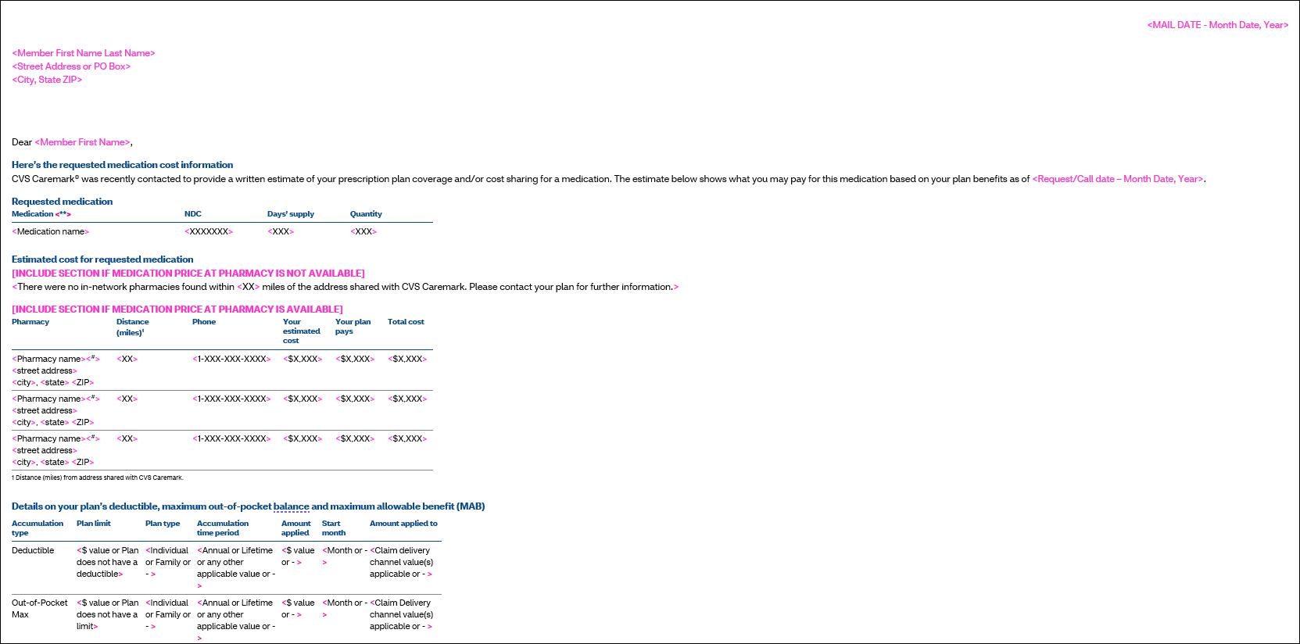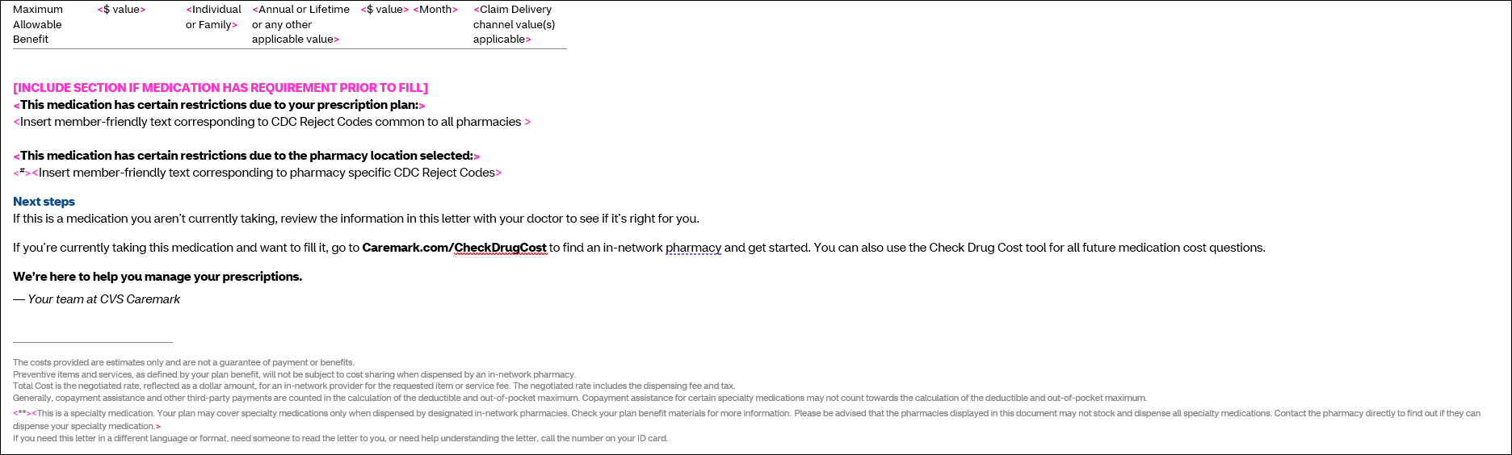

Top of the Document

|  |
| --- |
| **Related Documents** |

**Parent Document****:** [CALL 0049 Customer Care Internal and External Call Handling](https://policy.corp.cvscaremark.com/pnp/faces/DocRenderer?documentId=CALL-0049)

[Customer Care Abbreviations, Definitions, and Terms Index (017428)](https://thesource.cvshealth.com/nuxeo/thesource/#!/view?docid=c1f1028b-e42c-4b4f-a4cf-cc0b42c91606)

Top of the Document

Not to Be Reproduced or Disclosed to Others without Prior Written Approval

**ELECTRONIC DATA = OFFICIAL VERSION / PAPER COPY = INFORMATIONAL ONLY**